Lab#2
Design Form of Student Registration and Employee registration with 11 fields.
TAGS USED | ATTRIBUTES USED | DESCRIPTION
<!DOCTYPE html> | -- | Declares the document as an HTML5 document.
<html> | lang | Defines the root element of the HTML document. The lang attribute specifies the language of the webpage.
<head> | -- | Contains metadata, links, and information about the document that is not displayed on the webpage.
<meta> | charset, name, content | Specifies metadata such as character encoding and viewport settings for responsive design.
<title> | -- | Specifies the title of the webpage shown in the browser tab.
<body> | -- | Contains all the visible content displayed on the webpage.
<h1> | -- | Defines the main heading of the webpage.
<form> | action | Creates an HTML form for collecting user input. The action attribute specifies the page where form data is sent after submission.
<fieldset> | -- | Groups related form elements together within a border.
<legend> | -- | Provides a caption or title for a fieldset.
<label> | -- | Defines a label for a form control to improve readability and accessibility.
<input> | type, required, list, src, alt, height, width | Creates different types of input controls such as text fields, email fields, password boxes, radio buttons, checkboxes, date pickers, image buttons, submit buttons, and reset buttons.
<br> | -- | Inserts a single line break.
<select> | -- | Creates a drop-down list for selecting one option.
<optgroup> | label | Groups related options within a drop-down list.
<option> | -- | Defines an item within a drop-down list or datalist.
<datalist> | id | Provides predefined suggestions for an input element.
<button> | onclick | Creates a clickable button. The onclick attribute executes a JavaScript function when the button is clicked.
<script> | -- | Embeds or references JavaScript code used to add functionality to the webpage.

INPUT TYPE | DESCRIPTION
text | Accepts plain text input (Full Name).
email | Accepts and validates an email address.
password | Accepts password input with hidden characters.
tel | Accepts telephone number input.
number | Accepts numeric values only.
radio | Allows the user to select one option from a group (Gender).
file | Allows the user to upload a file.
color | Displays a colour picker.
search | Accepts search text input.
range | Displays a slider for selecting a value within a range.
url | Accepts and validates a website URL.
checkbox | Allows the user to select or deselect an option.
date | Allows the user to select a date.
time | Allows the user to select a time.
month | Allows the user to select a month and year.
week | Allows the user to select a week of the year.
datetime-local | Allows the user to select both date and time.
image | Displays an image that functions as a submit button.
submit | Submits the form data to the specified destination.
reset | Resets all form fields to their default values.

Final Outcome:
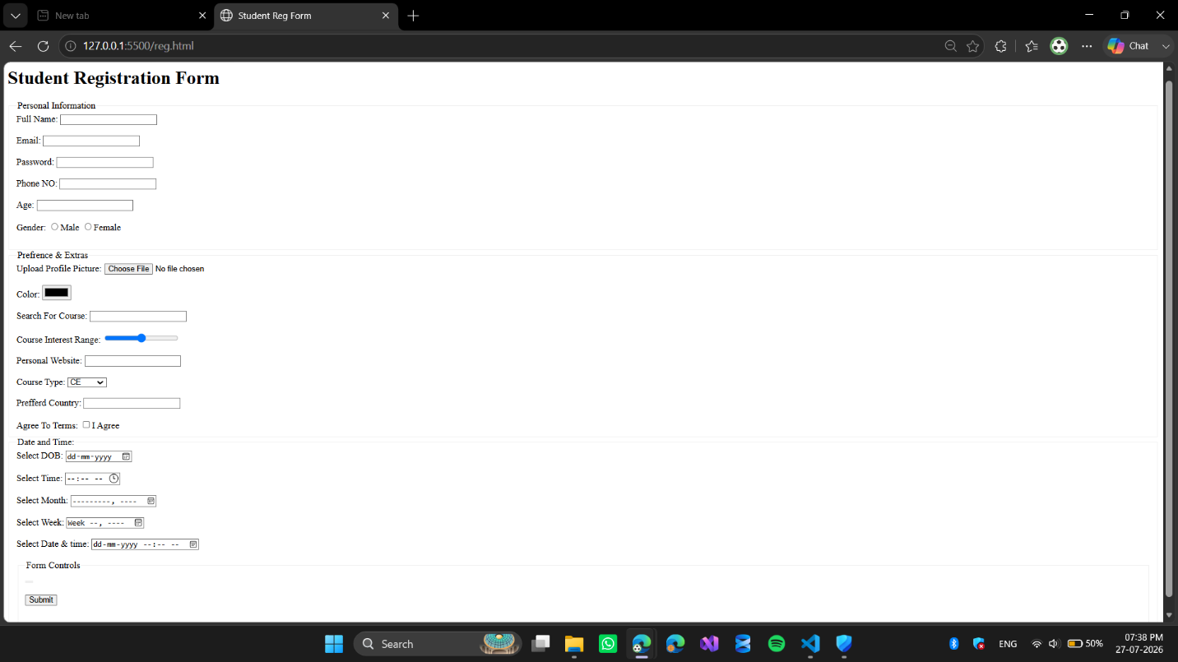

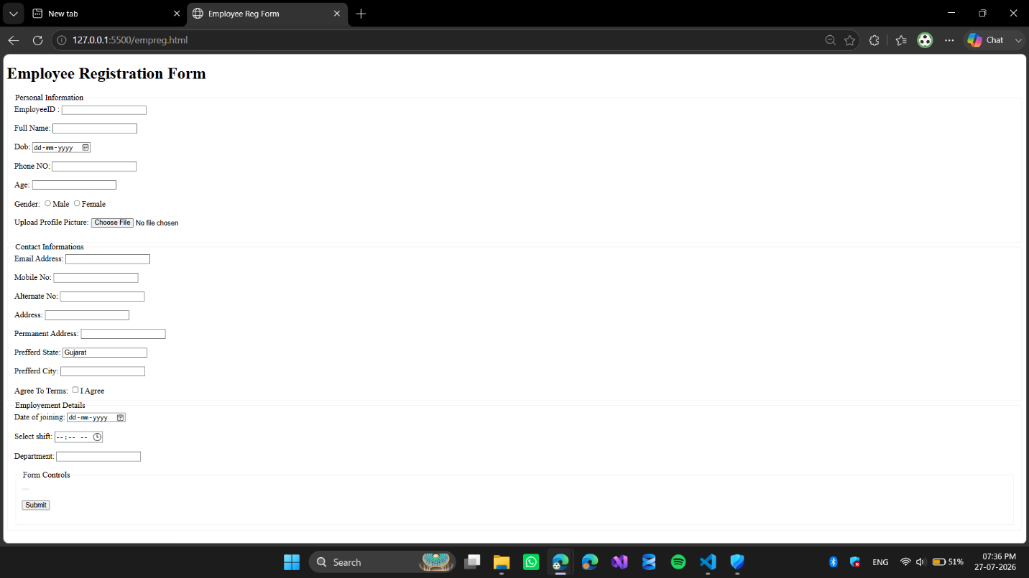

Code Snippet: Student Registration Form

<!doctype html>
<html lang="en">
<head>
<meta charset="UTF-8" />
<meta name="viewport" content="width=device-width, initial-scale=1.0" />
<title>Student Reg Form</title>
</head>
<body>
<h1>Student Registration Form</h1>
<form action="welcome.html">
<fieldset>
<legend>Personal Information</legend>

<label>Full Name:</label>
<input type="text" required/>
<br />
<br />

<label>Email:</label>
<input type="email" />
<br />
<br />

<label>Password:</label>
<input type="password" />
<br />
<br />

<label>Phone number:</label>
<input type="tel" />
<br />
<br />

<label>Age:</label>
<input type="number" />
<br />
<br />

<label>Gender:</label>
<input type="radio" /><label>Male</label> <input type="radio" /><label
>Female</label
>
<br />
<br />
</fieldset>

<fieldset>
<legend>Preferences & Extras</legend>

<label>Upload Profile Picture:</label>
<input type="file" />
<br />
<br />

<label>color:</label>
<input type="color" />
<br />
<br />

<label>Search for Course:</label>
<input type="search" />
<br />
<br />

<label>Course Interest Range:</label>
<input type="range" />
<br />
<br />

<label>Personal Website:</label>
<input type="url" />
<br />
<br />

<label>Course Type:</label>
<select>
<optgroup label="engg">
<option>CE</option>
<option>EE</option>
<option>ME</option>
<option>CIV</option>
</optgroup>
<optgroup label="Management">
<option>BBA</option>
<option>MBA</option>
</optgroup>
</select>
<br />
<br />

<label>Preferred Country:</label>
<input list="countries" />
<datalist id="countries">
<option>USA</option>
<option>UK</option>
<option>India</option>
<option>Japan</option>
</datalist>

<br />
<br />
<label>Agree to Terms:</label>
<input type="checkbox" /><label>I agree</label>
</fieldset>

<fieldset>
<legend>Date & Time Info</legend>

<label>Select Date of Birth: </label>
<input type="date" />
<br />
<br />

<label>Select Time: </label>
<input type="time" />
<br />
<br />

<label>Select month: </label>
<input type="month" />
<br />
<br />

<label>Select week: </label>
<input type="week" />
<br />
<br />

<label>Select date and time: </label>
<input type="datetime-local" />
<br />
<br />
</fieldset>

<fieldset>
<legend>Form Controls</legend>

<button onclick="sub()">Click Me</button>
<input type="image" src="butterfly.png" alt="Register Now" height="50" width="50" />
<br /><br />

<input type="submit" />
<br /><br />

<input type="reset" />
<br /><br />
</fieldset>
</form>
</body>
</html>

Code Snippet: Employee Registration Form

<!DOCTYPE html>
<html lang="en">
<head>
<meta charset="UTF-8">
<meta name="viewport" content="width=device-width, initial-scale=1.0">
<title>Employee Reg Form</title>
</head>
<body>
<h1>Employee Registration Form</h1>
<Form>
<fieldset>
<legend>Personal Information</legend>
<label>EmployeeID :</label>
<input type="text" required/>
<br/>
<br/>

<label>Full Name: </label>
<input type="text"/>
<br/>
<br/>

<label>Dob:</label>
<input type="date"/>
<br/>
<br/>

<label>Phone NO: </label>
<input type="tel"/>
<br/>
<br/>

<label>Age:</label>
<input type="number"/>
<br/>
<br/>

<label>Gender:</label>
<input type="radio"/>Male</label>
<input type="radio"/>Female</label>
<br/>
<br/>
<label>Upload Profile Picture:</label>
<input type="file">
<br/>
<br/>
</fieldset>
<fieldset>
<legend>Contact Informations</legend>

<label>Email Address:</label>
<input type="text">
<br/>
<br/>

<label>Mobile No:</label>
<input type="number">
<br/>
<br/>

<label>Alternate No:</label>
<input type="number">
<br/>
<br/>

<label>Address:</label>
<input type="text">
<br/>
<br/>

<label> Permanent Address:</label>
<input type="text">
<br/>
<br/>

<label>Prefferd State:</label>
<input list="States"/>
<datalist id="States">
<option>Gujarat</option>
<option>Rajasthan</option>
<option>Punjab</option>
<option>Madhya Pradesh</option>
</datalist>
<br/>
<br/>

<label>Prefferd City:</label>
<input list="Cities"/>
<datalist id="Cities">
<option>Rajkot</option>
<option>Surat</option>
<option>Junagadh</option>
<option>Udaipur</option>
<option>Indore</option>
</datalist>
<br/>
<br/>
<label>Agree To Terms:</label>
<input type="checkbox"><label>I Agree</label>
</fieldset>
<fieldset>
<legend>Employement Details</legend>
<label>Date of joining:</label>
<input type="date"/>
<BR />
<BR/>

<label> Select shift:</label>
<input type="time"/>
<BR />
<BR/>

<label>Department:</label>
<input list="Departments"/>
<datalist id="Departments">
<option>HR</option>
<option>IT</option>
<option>Finance</option>
<option>Marketing</option>
<option>Sales</option>
<option>Operations</option>
</datalist>
<BR />
<BR/>

<fieldset>
<legend>Form Controls</legend>
<button type="image" src="mulogo.png" alt="MU LOGO FOR REGISTER NOW" HEIGHT="50PX" ></button>
<BR/> <BR/>
<input type="submit"/>
<BR/> <BR/>
</fieldset>
</fieldset>
</Form>
</body>
</html>

